

**GROUP ASSIGNMENT**

**Course code:**

# TGEN133 PC Maintenance

**Subject：**

# TGEN133 PC Maintenance

**Lecturer:**

LEE JIA KHANG

**Group members:**

|  |  |
| --- | --- |
| Name | Students Id and course |
| Chong Hong Yao | 2370277-DCS |
| Wong Chee Hang | 2370088-DCS |
| Ng Kah Dung | 2370282-DCS |
| Quee You Xin | 2370283-DCS |

TOPIC

In this report we will briefly show the three systems we have assembled. The system is primarily designed for Photo, Video Editing and Rendering. The budget is RM5000.

SYSTEM 1

1.HARDWARE SELECTION

|  |  |
| --- | --- |
| CPU | AMD Ryzen 9 5900x |
| MOTHERBOARD | MSI MAG B550 Tomahawk |
| COOLER | DEEPCOOL AK620 Zero Dark |
| GPU | EVGA RTX 3080 10GB XC3 |
| RAM | Corsair Vengeance DDR4 32GB (16x2) 3600MHz |
| SSD | Samsung PCIe NVMe M.2 SSD 512GB Model: PM981 |
| HDD | WD 1TB hard drive 7200rpm and Seagate 16 TB HDD Exos X16 |
| PSU | Fsp hydro 700w power supply used |
| CASE | Aigo darkFlash A290 |

2.SOFTWARE

Operating System

* window 11 pro

Softwer Photo Editing

* Photoshop FREE TRIAL FOR 7 DAYS (RM65/M AFTER TRIALS)

Softwer Video Editing

* Davinci resolve FREE FOREVER AND PRO FOR RM1,490

3.TOTAL AMOUNT

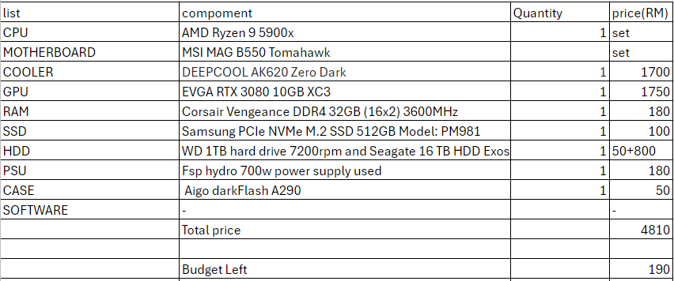

SYSTEM 2  
1.HARDWARE SELECTION

|  |  |
| --- | --- |
| CPU | AMD Ryzen 5 5600X |
| MOTHERBOARD | MSI B550M PRO-VDH WiFi |
| COOLER | Cooler Master Hyper 212 Halo |
| GPU | NVIDIA GeForce RTX 4060 8GB |
| RAM | Corsair Vengeance LPX 16GB (2x8GB) DDR4 3200MHz |
| SSD | Western Digital Blue SN580 1TB NVMe SSD *2 |
| HDD |  |
| PSU | Corsair CV550, 80 PLUS Bronze |
| CASE | NZXT H510 |

2.SOFTWARE

Operating System

* window 11 pro

Softwer Photo Editing

* Photoshop FREE TRIAL FOR 7 DAYS (RM65/M AFTER TRIALS)

Softwer Video Editing

* PowerDirector Essential FREE

3.TOTAL AMOUNT

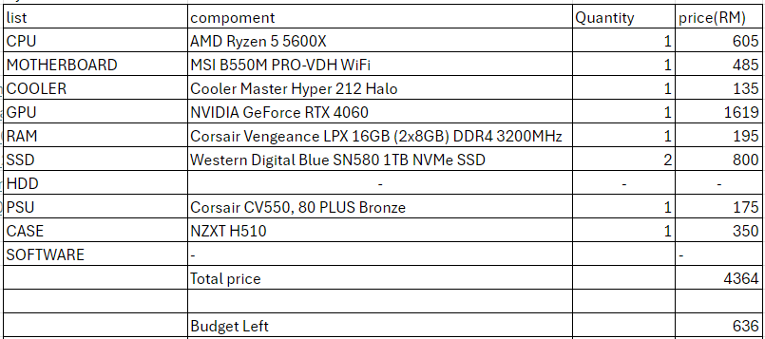

SYSTEM 3

1.HARDWARE SELECTION

|  |  |
| --- | --- |
| CPU | Intel® Core™ i7-12700K Processor |
| MOTHERBOARD | Intel® H610 (LGA 1700) mic-ATX motherboard |
| COOLER | Assassin X 120 Refined SE Single Tower CPU Heatsink Cooler (LGA1700) |
| GPU | Palit GeForce RTX3060 Dual 12GB GDDR6 Graphics Card |
| RAM | Kingston FURY Beast DDR4 RAM 16GB 3600MHz Desktop *2 |
| SSD | WD Blue SN570 M.2 2280 PCIe NVMe SSD 1TB |
| HDD | 1TB 7200 RPM 64MB Cache |
| PSU | Zalman Decamax 700W Power Supply |
| CASE | AVF-AC-MX3000 PREMIUM M-ATX TOWER PC CASE |

2.SOFTWARE

Operating System

* window 11 pro (free to use with watermark,pay to remove watermark RM1,299.00.)

Software Photo Editing

* GIMP
* Photoshop (free trial for 7 days, then RM67/mo)

Software Video Editing

* DaVinci Resolve 19(free to use with limit some limitation, pay to
* CapCut

Software Blender

* blender
* 3D Max

3.TOTAL AMOUNT

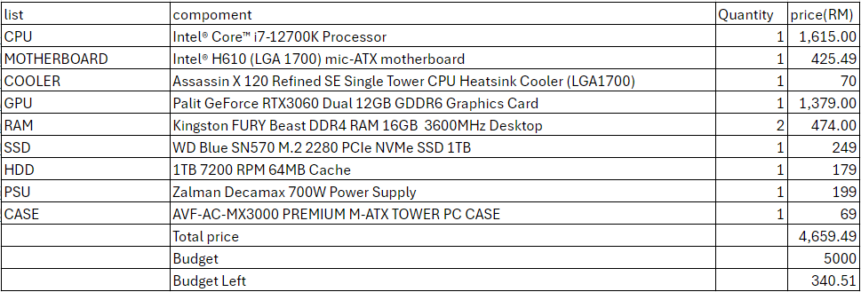

COMPARISONS

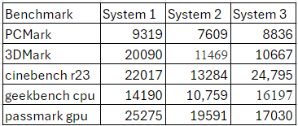

This is the benchmark score we calculate with 3DMARK. In this graph we can see all the Benchmark which is,PCMark,3DMark,cinebench r23,geekbench cpu,passmark gpu.  
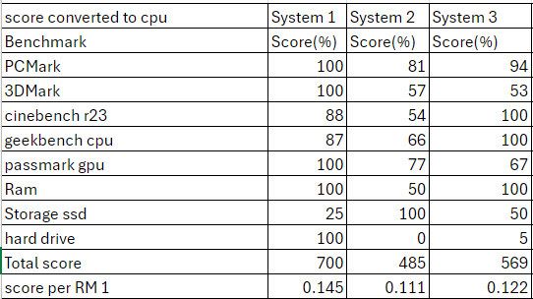

In this table, we can see the score and the score per RM1.We use a formula to calculate the score which is score divide by the highest score and multiply 100.For example, PCmark’s System 2, 7609 divide by 9319 multiply 100 equal 81.

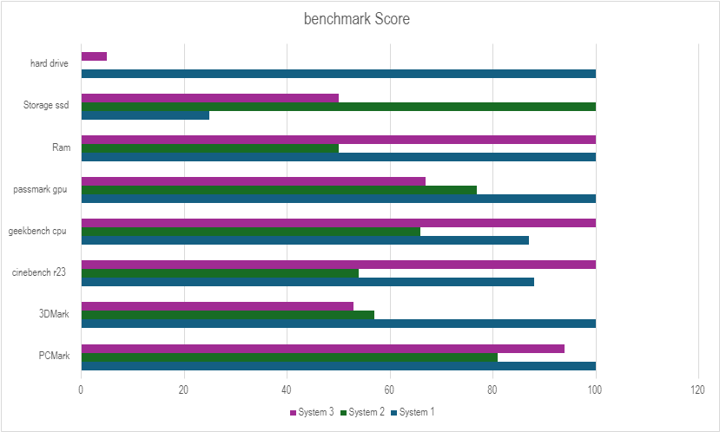

(GRAPH 1)

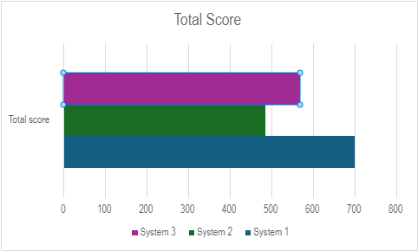

(GRAPH 2)

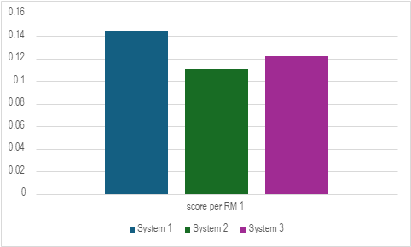

(GRAPH 3)

(USING TOTAL SCORE DIVIDED BY THE TOTAL PRICE)

CPU COMPARISONS

|  |  |  |  |
| --- | --- | --- | --- |
| Name | AMD Ryzen™ 9 5900X | AMD Ryzen™ 5 5600X | Intel® Core™ i7-12700K |
| Total Cores | 12 | 6 | 12 |
| Threads | 24 | 12 | 20 |
| Base Clock | 3.7 GHz | 4.6 GHz | 2.70 GHz |
| Boost Clock | 4.8GHz | 4.6GHz | 5.00 GHz |
| Total amount of Cache | 70MB | 35MB | 37MB |
| Default TDP | 105W | 65W | 125 W |
| Unlocked for Overclocking | Yes | Yes | Yes |
| Processor Technology for CPU Cores | TSMC 7nm FinFET | TSMC 7nm FinFET | 10 nm |
| Max operating Temperature(Tjmax) | 90°C | 95°C | 100 °C |
| Integrated Graphics | No | No | Intel® UHD Graphics 770 |
| PCI Express® Version | PCIe® 4.0 | PCIe® 4.0 | 5.0 and 4.0 |
| System Memory Type | DDR4 | DDR4 | DDR5 and DDR4 |
| System Memory Specification | Up to 3200 MT/s | Up to 3200 MT/s | Up to DDR5 4800 MT/s  Up to DDR4 3200 MT/s |
| Lauch Date | 11/5/2020 | 11/5/2020 | **4/11/2021** |
| Price | RM1100 | RM605 | **RM1615** |

The AMD Ryzen 9 5900X has more cores and threads than the Ryzen 5 5600X and Intel i7-12700K, making it the best choice for multi-threaded tasks. The Intel i7-12700K combines high-performance cores and efficiency cores, providing a good balance in multi-threaded and single-threaded applications, and tends to outperform the Ryzen 9 5900X in some single-threaded applications. Although the i7-12700K has high-performance cores and efficiency cores, it is more expensive. The Ryzen 5 5600X is a more cost-effective choice for gaming and medium-load work. In summary, we chose the AMD Ryzen 9 5900X. Although its performance is not higher than the Intel i7-12700K, it is not bad at all. If you want the best performance for the budget, the AMD Ryzen 9 5900X will be a good choice.

GPU

|  |  |  |  |
| --- | --- | --- | --- |
| Name | EVGA RTX 3080 10G XC3 | RTX 4060 8GB | RTX3060 12GB |
| Gpu name | [GA102](https://www.techpowerup.com/gpu-specs/nvidia-ga102.g930) | [AD107](https://www.techpowerup.com/gpu-specs/nvidia-ad107.g1015) | [GA106](https://www.techpowerup.com/gpu-specs/nvidia-ga106.g966) |
| Process Size | 8 nm | 5 nm | 8 nm |
| Transistors | 28,300 million | 18,900 million | 12,000 million |
| Shading Units | 8704 | 3072 | 3584 |
| Base clock | 1440 MHz | 1830 MHz | 1320 MHz |
| Memory Clock | 1188 MHz  19 Gbps effective | 2125 MHz  17 Gbps effective | 1875 MHz  15 Gbps effective |
| Boost Clock | 1710 MHz | 2460 MHz | 1777 MHz |
| RT Cores | 68 | 24 | 28 |
| TDP | 320W |  | 170 W |
| Memory Size | 10GB | 8 GB | 12GB |
| Memory Type | GDDR6X | GDDR6 | GDDR6 |
| Memory Bus | 320 bit | 128 bit | 192 bit |
| Memory Bandwidth | 760.3 GB/s | 272.0 GB/s | 360.0 GB/s |
| Bus Interface | PCIe 4.0 x16 | PCIe 4.0 x8 | PCIe 4.0 x16 |

**Transistors & Shading Units**

The RTX 3080 has significantly more transistors and shading units than both the RTX 4060 and RTX 3060. **Transistors** are crucial for overall processing power, and **shading units** (or CUDA cores) are critical for tasks like rendering and 3D modeling. The RTX 3080's higher count means it can handle more complex computations simultaneously, making it ideal for video editing, rendering, and other GPU-intensive tasks.

### **RT Cores (Ray Tracing)**

The **RTX 3080** has a significantly higher number of RT Cores compared to the other two. RT Cores are specialized for real-time ray tracing, a technique that simulates the way light interacts with objects in a scene to produce realistic images. More RT Cores mean better performance in rendering tasks that use ray tracing, which can be particularly useful in certain types of video editing and rendering workflows.

**CONCLUSION**

Our final choice is System 1 even it has the highest price between the 3 system. It is because System 1 have the highest benchmark score (GRAPH 1).Besides that, it also has the highest performance-price ratio which is 0.14/Rm1 (GRAPH 3).Below, I will briefly compare the hardware between System 1,2 and 3.

**Higher Performance CPU**

* The AMD Ryzen 9 5900X has 12 cores and 24 threads, which significantly enhances performance in multi-threaded applications like video editing and rendering. This is crucial for software such as Adobe Premiere Pro, After Effects, and other professional editing tools.

**More Powerful GPU**

* While not as critical as the CPU for editing, the EVGA RTX 3080 10GB provides excellent support for GPU-accelerated tasks in editing software, significantly speeding up effects rendering, 3D modeling, and other GPU-intensive processes.

**Larger RAM Capacity**

* With 32GB of RAM, System 1 is better equipped to handle large photo and video files, multiple layers, and complex projects. This capacity ensures smoother performance and faster rendering times compared to the 16GB in Systems 2 and 3.

**Efficient Storage Setup**:

* The combination of a fast 512GB NVMe SSD for the operating system and applications, along with a 16TB HDD for storage, offers both speed and ample storage space. This is ideal for storing large video files and extensive photo libraries, ensuring quick access and sufficient capacity.

Reference

<https://www.pcmag.com/how-to/how-to-build-a-pc-the-ultimate-beginners-guide>

<https://www.wired.com/story/how-to-build-a-pc/>

<https://www.digitaltrends.com/computing/how-to-build-a-pc/>

<https://www.3dmark.com/search>

<https://www.techpowerup.com/gpu-specs/geforce-rtx-3080.c3621>

<https://www.videocardbenchmark.net/gpu_list.php>

<https://browser.geekbench.com/processor-benchmarks>

<https://nanoreview.net/en/cpu-list/cinebench-scores>

<https://benchmarks.pugetsystems.com/benchmarks/>